Weather Dashboard: Project & Docker Summary
Data Science project, Zainab

1. Project Overview
The Weather Dashboard is a full-stack web application that collects weather data for seven cities of Pakistan (Karachi, Lahore, Islamabad, Peshawar, Quetta, Multan and Faisalabad). For each city it records the minimum and maximum temperature, current weather condition and sunshine status. The data is stored in Firebase Firestore, analysed and visualised with Python (Seaborn), and shown on a React website.
Backend | Python, Flask, Seaborn, gunicorn
Frontend | React.js (Vite)
Database | Firebase Firestore
Data source | Open-Meteo API (7 cities of Pakistan)
Containers | Docker, Docker Compose, Docker Hub

2. How the Application Works
- collect_weather.py fetches today's weather from Open-Meteo and saves it to Firestore.
- The Flask API (app.py) reads Firestore and returns JSON, and generates Seaborn charts as images.
- The React frontend shows city cards, highlights and four charts (min vs max, sunshine, conditions, trend).
- A "Refresh data" button re-runs the collector and updates the page.

3. Dockerization
The application was containerised so it runs the same way on any computer. A main Dockerfile packages the Python backend and the React frontend into one image (weather-app-image), and docker-compose.yml runs it with the correct ports. The Firebase key is not stored in the image. It is mounted at run time, and a .dockerignore file keeps it out of the build.
Steps followed:
- Wrote the Dockerfile and docker-compose.yml.
- Built the image from the project folder:
docker build -t weather-app-image .
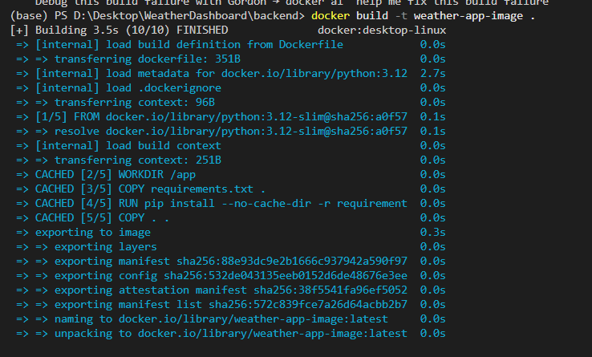
Figure 1: Building the image with docker build
- Built and started the services with Docker Compose:
docker compose up --build -d
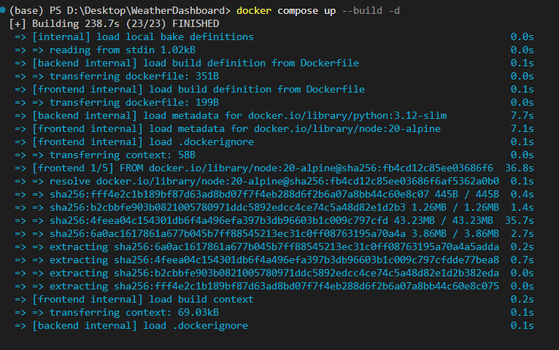
Figure 2: docker compose up --build -d
- Checked the images in Docker Desktop:
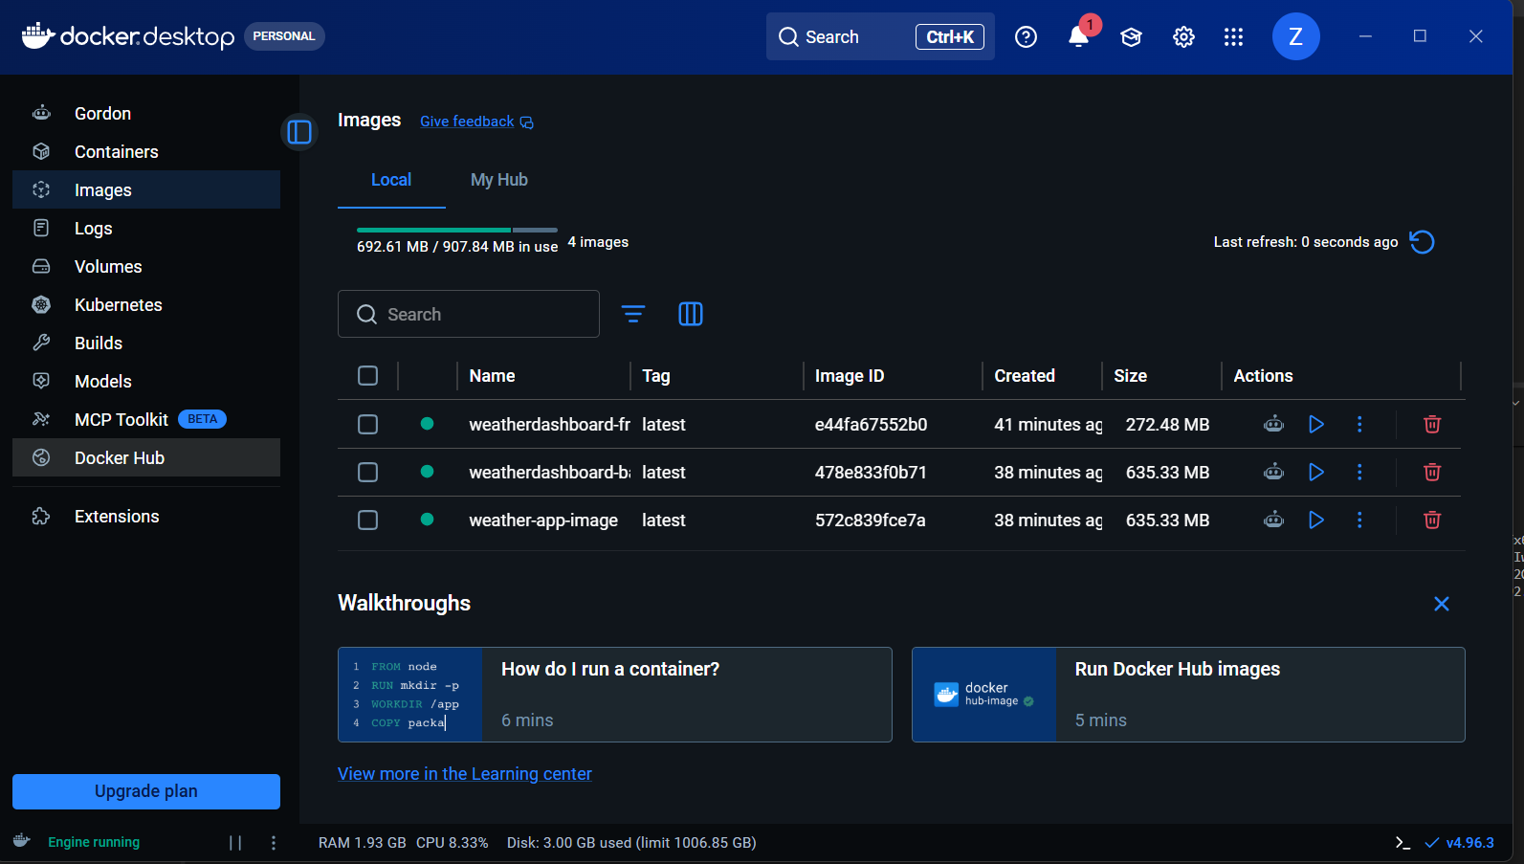
Figure 3: Images listed in Docker Desktop

4. Uploading the Image to Docker Hub
The image was tagged with the Docker Hub username and pushed so it can be pulled on any machine:
docker tag weather-app-image zainababbas608/weather-app-image:latest
docker push zainababbas608/weather-app-image:latest
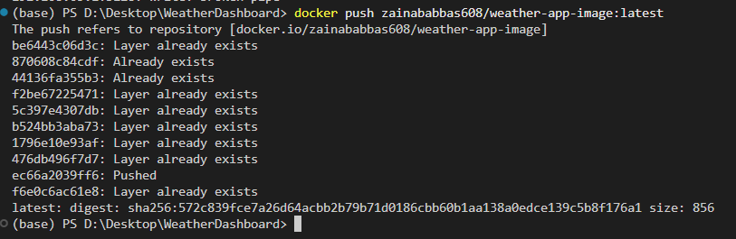
Figure 4: Successful docker push to Docker Hub

5. Running the Application
docker compose up -d
# open http://localhost:5173
docker compose down # to stop
The website runs on port 5173 and the API on port 5000.

6. Conclusion
Docker makes the project easy to run and share. The same image works on any computer that has Docker installed, with no need to install Python, Node.js or the project libraries separately.

